Ashley McTee
English 2010-054
Group 9
Position/Proposal

Recession’s Effects on Healthcare: Who is More Impacted?

Abstract

This report will provide some eye opening information on the current recession and how it is a vicious cycle that impacts almost every one whether you work in healthcare or are just trying to obtain insurance to get proper medical attention.

Who is impacted?

General Public
Since the current recession started in December 2007 the total number of uninsured in the United States has drastically increased. This has been happening whether a person is employed or is unemployed.

Employed

If you are employed and have insurance coverage through work you may possibly see a gradual increase in the premiums you are paying for specific coverage. This is your employer’s way of adapting to the pressures of the economic turmoil. They see this as the best way so they don’t have to get rid of healthcare benefits altogether. How sweet of them you might say, but even with them increasing the premiums all they are trying to do is pick up the slack. Not everyone would opt for signing up for insurance because some may not see it as a necessity or they just choose to not get coverage due to needing to purchase consumer goods or save up for future education or retirement.
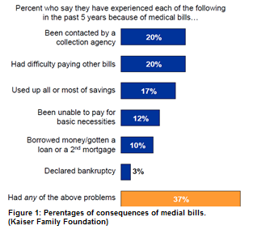
Paying for the insurance through an employer or private insurer may be no issue for some, but for others who have insurance it’s the medical bills that cause some major issues. Medical bills have led to a variety of consequences for families according to the Kaiser Family Foundation (Figure1). Reports state that the major impact the medical bills have had on families is bankruptcy. Some may have to file Chapter 7 bankruptcy due to being so far in debt due to medical bills. Some people feel that there is no other way out of their medical bill debt so they turn to bankruptcy.

Unemployed

For the employed the grass is definitely not greener when it comes to having insurance coverage. Currently there are 50.7 million uninsured Americans, that is 16.7% of the current population according to the U.S. Census Bureau. The Census Bureau has found that a loss in coverage is tied to the increasing number of unemployed losing their employer coverage. Underneath the COBRA Act if a person is laid off they are allowed to keep their health coverage for up to 18 months after being released from their employer. Most are not choosing to sign up for this due to a high premium cost once they are unemployed.
When a person is unemployed if they still can afford insurance they tend to reach out to private insurers. The number of people signing up for private insurance is increasing as well. Ron Pollack, an executive director for Families USA who is an advocacy group stated, “The recession has eroded private insurance coverage as millions of Americans lost their jobs. When people lose their jobs, it makes enormous sense to expect that the number of people without health insurance will increase.”
Unemployed adults aged 18–64 years are less likely to have private insurance and more likely to be uninsured than employed adults. In 2009–2010, three quarters (75.1%) of employed adults aged 18–64 years had private health insurance coverage; more than four in five (81.4%) had either public or private insurance (Figure 2). Less than one-half (48.1%) of unemployed adults had any health insurance coverage. Of those with coverage, 59% had private coverage and 41% had public health insurance.
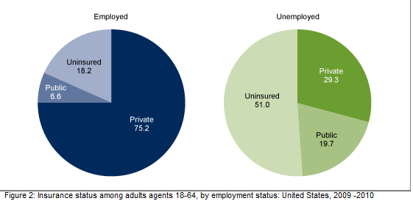

Private Practitioners

Since the healthcare system isn’t immune to recession current healthcare providers like private medical practitioners are feeling the impact of the recession. They are in a constant battle with people being uninsured or underinsured and are seeking medical treatment but are unable to pay the bills. Doctors are seeing more uninsured patients or patients that are unable to pay their medical bills and co-pays than those who are not underinsured. Information obtained from the Census provided more detailed information regarding how many people are uninsured and were able to compare it to recent years that the U.S has experienced a recession from 1987 to 2008. (Figure 3)
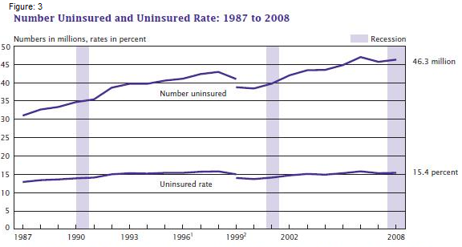
With the uninsured rate increasing and the practitioners taking a hit financially it is causing some to seek other opportunities to obtain extra income such as providing an on- call service, extending office hours or taking on essentially a second job at a hospital. But they may run into problems because not only are some private practices closing but hospitals are cutting back expenses and staff just to make ends meet.
Another way medical practitioners are being impacted is them not being reimbursed for their services in a timely manner if at all. A main source of their revenue is based off providing patient services which is either paid by the patients or their health insurance. The reimbursement process is commonly done through a third party which causes it to be a long drawn out process. If the person who received the services is unable to pay it impacts their revenue until it is paid. If the bills aren’t paid the practitioners have to send them off to a collection agency. When this happens the doctors on average will lose about 50% of the money that they would have earned if the bill was paid in a timely manner.

Proposed Solutions

Current Healthcare Reform

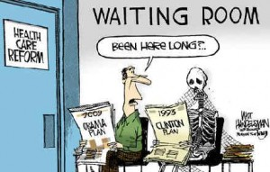
Healthcare reform has been a constant debate since the 19th century. It wasn’t until March 23, 2010 when the Patient Protection and Affordable Care Act (PPACA) was passed and signed by current President Barak Obama that there was a healthcare reform set in place. The reform that has been set up to help our healthcare system and the general public afford the coverage they need. This reform provides an individual the right to cheaper healthcare, which can provide a good outlook for economic productivity. When people have access to health care, they live healthier and longer lives, thus allowing them to contribute to society for a longer time. The cost of bad health and shorter life spans of Americans suffering from not being insured is not only impacting them but the overall economy.
This reform is set up to help not only the employed but the unemployed as well. By 2014 the PPACA will user in a new era for the unemployed by providing them a variety of options for affordable and comprehensive healthcare. When this is fully implemented it will make it to where the COBRA system won’t have to be extended to provide benefits for the unemployed and uninsured because health insurance would be more affordable.

Conclusion

In conclusion it appears that the recessions effects on healthcare is a vicious cycle that impacts everyone and the cycle could be broken with the Patient Protection and Affordable Care Act (PPACA). This act will assist in helping everyone get the health insurance coverage that they need no matter if they are employed or unemployed that way everyone will be able to live healthy lives with coverage.

Works Cited
"Economic Problems Facing Families." Survey Brief: Economic Problems Facing Families.
Henry Keiser Foundation, Apr. 2008. Web. 23 Feb. 2012. <http://www.kff.org/kaiserpolls/7773.cfm>.
"Filing Bankruptcy Statistics & Economic News." Medical Bankruptcy Statistics and Information. TotalBankruptcy, LLC, 2010. Web. 23 Feb. 2012. <http://www.totalbankruptcy.com/filing-bankruptcy-statistics/falling-into-medical- bankruptcy.html>.
"Insurers Battle over Health Care Implementation." Insurance Business and Money Saving Quotes. Web. 23 Feb. 2012. <http://www.insurancebusiness.org/insurers-battle-over- healthcare.html>.
Lowery, George. "Cornell Chronicle: 9 Million Lost Insurance during Recession." Cornell
Chronicle Online. Cornell University, 11 Dec. 2011. Web. 23 Feb. 2012. <http://www.news.cornell.edu/stories/Dec11/CawleyInsurance.html>.
National Health In Surance—A Brief History of Reform Efforts in the U.S. Keiser Foundation,
Mar. 2009. Web. 04 Feb. 2012. <http://www.kff.org/healthreform/upload/7871.pdf>.
"Patient Protection and Affordable Care Act." The U.S. Department of Labor Home Page.
United States Department of Labor, Mar. 2010. Web. 23 Feb. 2012. <http://www.dol.gov/ebsa/healthreform/>.
"Products - Data Briefs - Number 83 - January 2012." Centers for Disease Control and
Prevention. Jan. 2012. Sat. 23 Feb. 2012
<http://www.cdc.gov/nchs/data/databriefs/db83.htm>.

